**MEMO**

TO: Supervisor, Gillian Saunders

FROM: Engineering Team Lead, Arfaz Hossain

DATE: February 16, 2023

SUBJECT: Prototype Design Proposal: Autonomous Sensor-Cleaning Robot

Proposal Request

I am reaching out to inform you of an opportunity for our company to respond to a Request for Proposals from Ocean’s Network Canada (ONC) for a prototype design of an autonomous sensor-cleaning robot. ONC operates world-leading observatories to help researchers around the globe, and as part of their observations, they oversee a variety of underwater instruments, sensors, send cameras to gather and disseminate a wide range of data, including information about conditions on the ocean bed, water quality, biodiversity, and marine environment.

As per the proposal, ONC is seeking a solution to address the issue of sedimentation, falling debris, and biofouling that obscures the cameras of their observatories and negatively impacts the data collection of many of the sensors. Ocean’s Network is inviting external proposals for the research, design, construction, and development of a prototype that can be capable of finding the underwater target object using specific IR signal, maneuvering in a safe manner, and positioning a cleaning device on top of the camera or other target objects.

Our Expertise in Automated Robotics

Our company is an ideal candidate to respond to this proposal and secure the contract. Both our design and automation engineering team possess a diverse set of skillsets in the field of automated robotics, including expertise in sensor-integrated control systems. Our experience in designing and building automated systems for many under-oil environments in Alberta has equipped us with the essential knowledge and expertise to address the unique challenges present in most underwater environments such as high water-pressure, corrosion, biofouling, sedimentation, underwater debris and most importantly, visibility. We have a record of creating effective, durable, and long-lasting automated sensor-integrated systems that have proven to withstood harsh conditions and extreme temperatures in under-oil environments. With years of experience in developing specialized robots for various menial tasks in Alberta Oil Rigs, our team is well equipped to tackle the challenge of creating a sustainable robot. I am confident in our design and automation engineering team to successfully develop and deliver an effective solution for this proposal.

Initial Conceptual Design

Our initial design for the robot can feature a legged, multi-vectored spherical design with a six-axis torque sensor at its centre.[1] The torque sensor, like those used in our previous autonomous systems, will allow precise maneuvering of the robot through controlling its longitudinal and lateral motion, rotatory motion, sinking and floating motion, as well as cruising motion.[2] This would also allow for a safer maneuverability in the sensitive ecology of the underwater environment.[1] We are also planning to integrate a control system in our design which would allow remote operations and monitoring in case of any accidents or emergencies, ensuring safety and flexibility.[3]

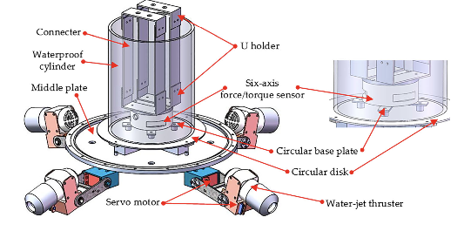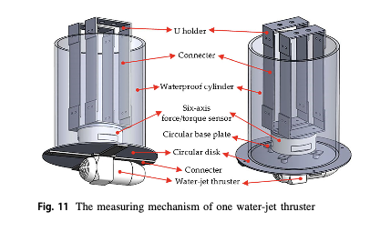

Figure 1: The Initial conceptual design of the multi-vectored spherical robot (Adapted from *Design, modeling, and experimental evaluation of a legged, multi- vectored water-jet composite driving mechanism for an amphibious spherical robot* by Huiming et al., 2019)

­­

Our current design for the robot does not yet include a dedicated surface-cleaning mechanism, but we are considering incorporating a cleaning system within the integrated control system. This system will be capable of executing cleaning commands and potentially utilizing advanced technologies such as ultrasonic or high-pressure water jets for optimal cleaning results.[2] In short, our conceptual robot can include the following features:

|  |  |  |
| --- | --- | --- |
| Features | | Description |
| Axial Design | Featuring six redundant compartments and a waterproof central compartment, ensuring that the robot can operate even in the event of partial damage, with at least three compartments intact. | |
| Six-Legged Design | Allows the robot to move in six different directions along the centre axis.  Allows for stability and safer maneuverability in challenging terrain. | |
| Sustainable Design | Equipped with a system to collect and store waste generated during cleaning operations, ensuring that it operates in an environmentally responsible manner. | |
| Torque Sensor | Enables precise control of the robot's movement | |
| Sensor Integrated Control System | Allows for remote operation and monitoring, providing safety and flexibility | |
| Surface Cleaning Mechanism | Equipped with a mechanism for cleaning surfaces on command. | |
| Real Time Reporting | Sends a *location* signal with the real time coordinates  Sends a *completion* signal after each completion of tasks | |
| Exit On Command | Allows the operator to safely disengage the robot and shut it down remotely in case of any unexpected incidents or emergencies. | |

Final Thoughts

We recognize the significance of sustainability and thus demonstrating our commitment to it through integrating energy-saving features and utilizing recyclable, materials in our design, will increase the likelihood of securing the contract. This will not only align with the values of Oceans Network but also demonstrate our capability as a responsible and innovative company.

**Citations**:

1. R. An, S. Guo, Y. Yu, C. Li, and T. Awa, “Multiple Bio-Inspired Father–Son Underwater Robot for Underwater Target Object Acquisition and Identification,” *Micromachines*, Dec. 2021 [Online] *dx.doi.org/10.3390/mi13010025*
2. Y. Li, S. Guo, and Y. Wang, “Design and characteristics evaluation of a novel spherical underwater robot,” *Robotics and Autonomous Systems*, vol. 94, pp. 61–74, Aug. 2017 [Online] *doi.org/10.3390/mi13010025*
3. H. Xing, S. Guo, L. Shi, X. Hou, Y. Liu, and H. Liu, “Design, modeling and experimental evaluation of a legged, multi-vectored water-jet composite driving mechanism for an amphibious spherical robot,” *Microsystem Technologies*, vol. 26, no. 2, pp. 475–487, Jul. 2019 [Online] doi.org/10.1007/s00542-019-04536-7
4. R. Wang, S. Wang, Y. Wang, M. Cai and M. Tan, "Vision-Based Autonomous Hovering for the Biomimetic Underwater Robot—RobCutt-II," in IEEE Transactions on Industrial Electronics, vol. 66, no. 11, pp. 8578-8588, Nov. 2019 [Online] doi.org/10.1109/TIE.2018.2886755.